Project Design Phase-II

Technology Stack (Architecture & Stack)

|  |  |
| --- | --- |
| **Date** | **17 October 2022** |
| **Team ID** | **PNT2022TMID03339** |
| **Project Name** | **Emerging methods for early detection**  **of forest fires** |
| **Maximum Marks** | **4 Marks** |

Technical Architecture

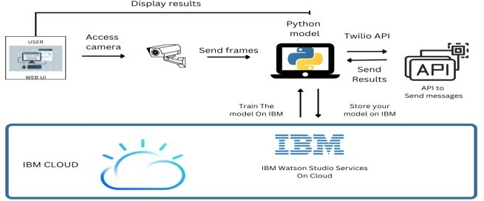

Table-1 : Components & Technologies

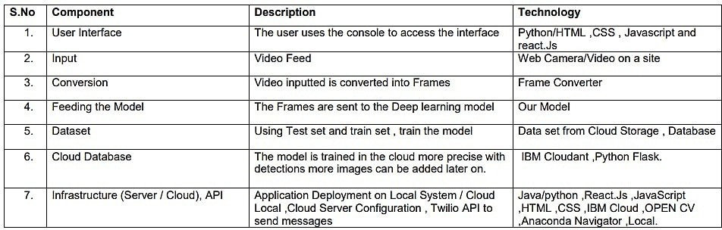

Table-2: Application Characteristics

